1. **Take an integer number from the user and check if the number is bigger than 10 or not.**

#include<stdio.h>

int main()

{

int n;

scanf("%d",&n);

if(n>10)

printf("Yes\n");

else if(n==10)

printf("Equal\n");

else

printf("No\n");

return 0;

}

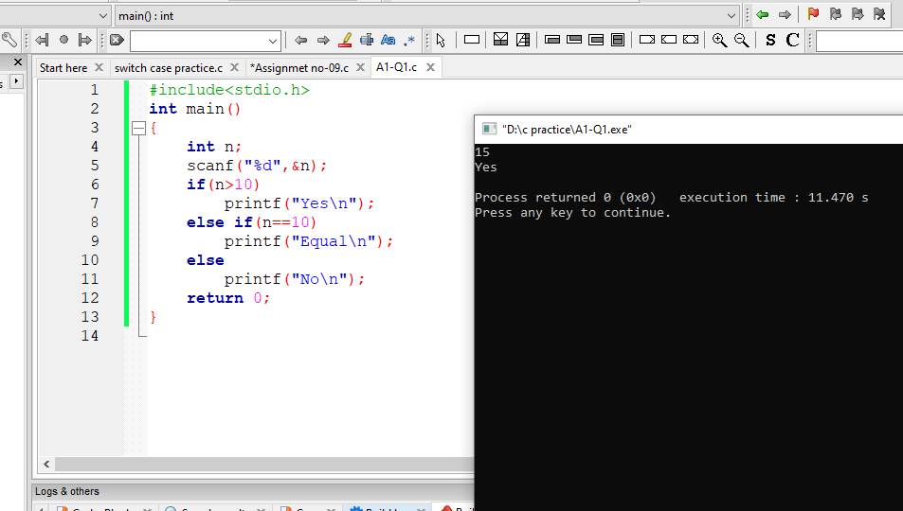

1. **Take two numbers from the users and find the maximum and minimum number of those two numbers.**

#include<stdio.h>

int main()

{

int n1,n2;

printf("Enter Two numbers:");

scanf("%d %d",&n1,&n2);

if(n1>n2)

printf("%d is maximum\n",n1);

else

printf("%d is maximum\n",n2);

return 0;

}

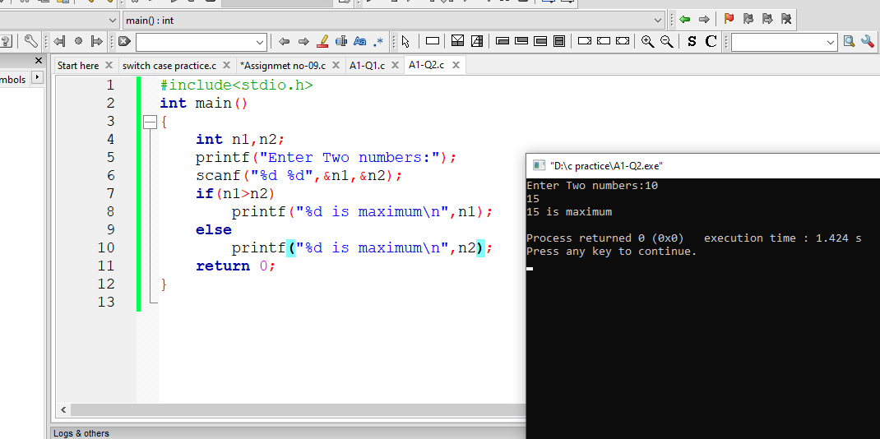

1. **Write a C program to check whether a given number is divisible by 4 and 400.**

#include<stdio.h>

int main()

{

int n;

printf("Enter the number:");

scanf("%d",&n);

if(n%4==0 && n%400==0)

printf("%d is divisible by both 4 & 400\n",n);

else

printf("Not divisible\n");

return 0;

}

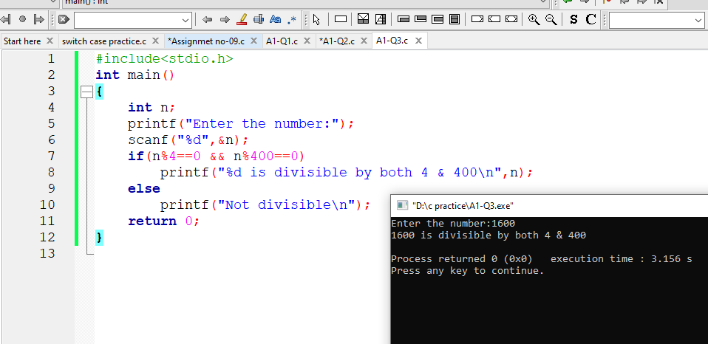

1. **Write a C program to check whether the number is even or odd**

#include<stdio.h>

int main()

{

int n;

printf("Enter the number: ");

scanf("%d",&n);

if(n%2==0)

printf("%d id Even\n",n);

else

printf("%d is odd\n",n);

return 0;

}

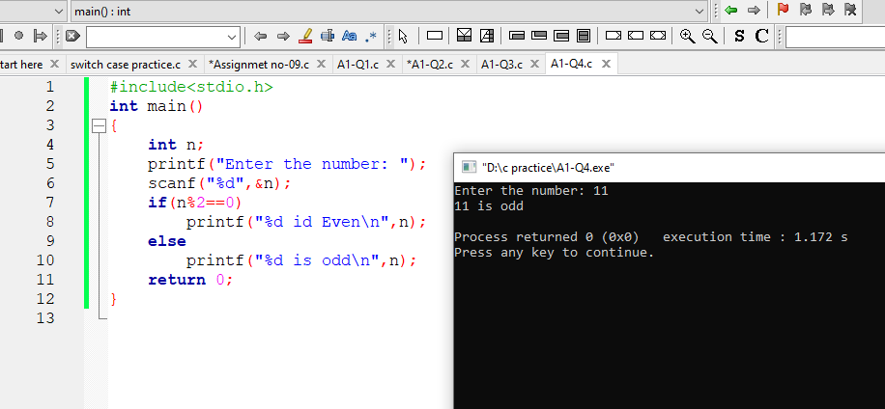

1. **Take a letter as input from the user and determine whether that letter is a vowel or consonant**

#include<stdio.h>

int main()

{

char ch;

printf("Enter a letter : ");

scanf("%c",&ch);

if(ch=='a' || ch=='e' || ch=='i' || ch=='o' || ch=='u' ||

ch=='A' || ch=='E' || ch=='I' || ch=='O' || ch=='U')

printf("%c is vowel\n",ch);

else

printf("%c is conconent\n",ch);

return 0;

}

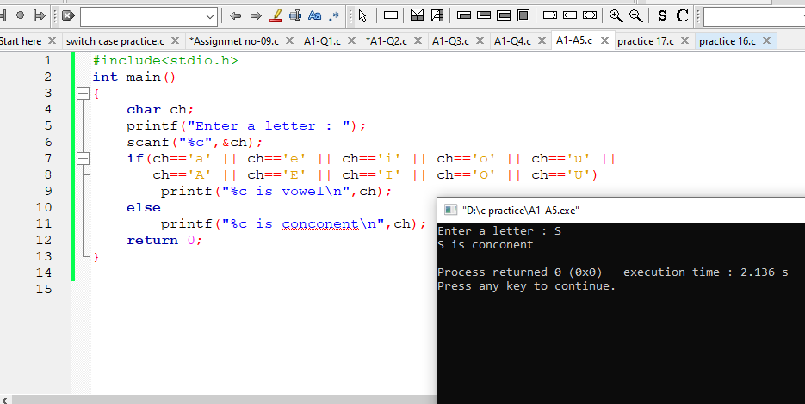

1. **Write a C program to check whether a character is an alphabet, digit, or special character**

#include<stdio.h>

int main()

{

char x;

printf("Enter a letter: ");

scanf("%c",&x);

if(x>='a' && x<='z' || x>='A' && x<='Z')

printf("Alphabate");

else if(x>='0' && x<='9')

printf("Digit");

else

printf("Special Character");

return 0;

}

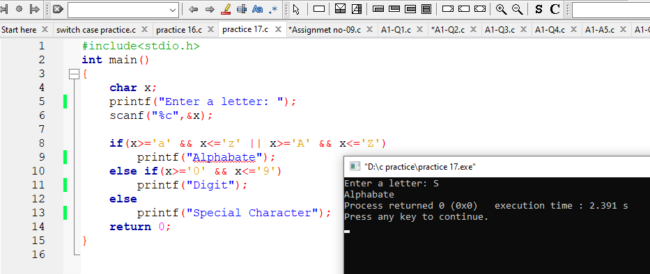

**7. Take Three numbers from the user and find the maximum number among those three numbers using nested if else.**

#include<stdio.h>

int main()

{

int n1,n2,n3;

printf("Enter three numbers: ");

scanf("%d %d %d",&n1,&n2,&n3);

if(n1>n2 && n1>n3)

printf("%d is maximum\n",n1);

else if(n2>n3 && n2>n1)

printf("%d is maximum\n",n2);

else

printf("%d is maximum\n",n3);

return 0;

}

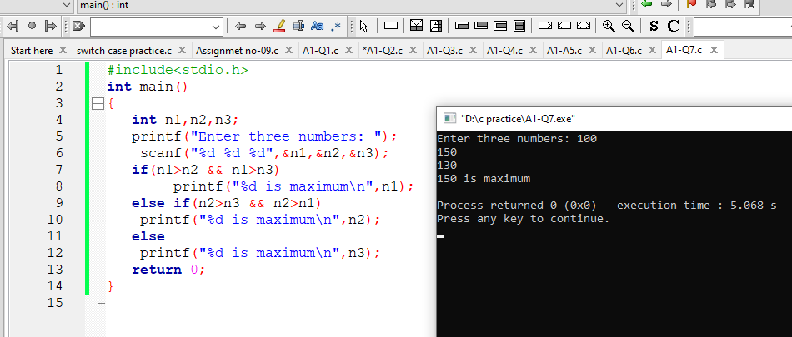

**8,Write a C program to print the day of the week’s name using the switch case.**

#include<stdio.h>

int main()

{

int n;

printf("Day number(1-7):");

scanf("%d",&n);

switch(n)

{

case 1:

printf("Saturday\n");

break;

case 2:

printf("Sunday\n");

break;

case 3:

printf("Monday\n");

break;

case 4:

printf("Tuesday\n");

break;

case 5:

printf("Wednesday\n");

break;

case 6:

printf("Thursday\n");

break;

case 7:

printf("Friday\n");

break;

default:

printf("Not a correct option");

}

}

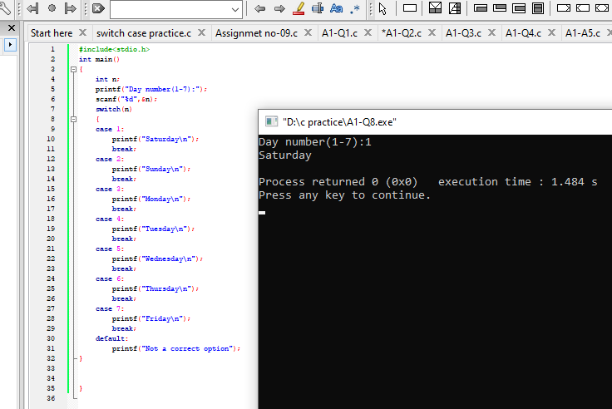

**9,Write a C program to create a calculator using switch case and functions**

#include<stdio.h>

int main()

{

float a,b;

char c;

scanf("%f %c %f",&a,&c,&b);

switch(c)

{

case '-':

printf("%.3f\n",a-b);

break;

case '+':

printf("%.3f\n",(a+b));

break;

case '*':

printf("%.3f\n",(a*b));

break;

case '/':

printf("%.3f\n",a/b);

break;

default :

printf("Not match\n");

}

}

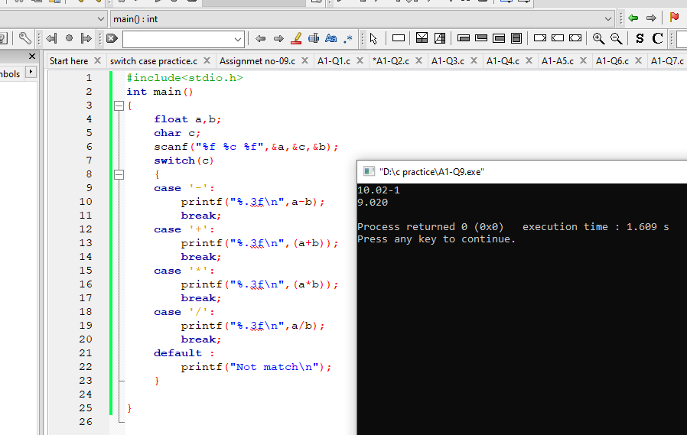

**Name:Ashraful Islam Redoy**

**ID:0242320005101178**